Journey Assimilation Process

2005

OUTLINE

Journey Assimilation Process: The Purpose and Assumptions

Executive Summary
  - First Time Visit
  - Second Time Visit
  - Regular Attender

I. Step #1: From First Time Guest to Second Time Guest
A. Pre-service: First Contact
B. During Service: Connection Card
C. Post-Service Gift: Free Book
  - Post-Service Information: Fresh Start Table
  - Post-Weekend: Follow-Up

- Step #2: From Second Time Guest to Regular Attender
  - During Service: Connection Card
  - Post-Weekend: Follow-Up
  - Post-Weekend: Engagement Opportunities

- Step #3: From Regular Attender to Member
  - During Service:
    - Service Opportunities
    - Teaching on Membership & Baptism
    - Signing-up for Membership & Baptism
  - Post-Weekend: Small Groups

Appendix
A. Connection Card
B. First Time E-mail
  - First Time Guest On-Line Survey
  - First Time Card
  - First Time One-Month Follow-Up Letter
  - Second Time E-mail
  - Second Time Letter
  - Service Team Card
  - Why Do You Need a Spiritual Family
  - Baptism E-mail
  - Membership Class E-mail
  - Membership Covenant

Journey Assimilation Process: The Purpose and Assumptions

Purpose: The Journey exists to give the people of New York City the best opportunity to become fully developing followers of Jesus.

As a part of this overall purpose, The Journey’s Assimilation Process exists to move people forward along a three-step process:

- From being first time guests to becoming second time guests
- From being second time guests to becoming regular attenders
- From being regular attenders to becoming fully developing members.

An Assumption of this strategy is the belief that once a person becomes a fully engaged member (a person working out the 5 purposes in his or her life at The Journey) they are experiencing real life transformation and as a result are in the process of becoming a fully developing follower of Jesus (the ultimate purpose of the church).

As a result, the goal and purpose of assimilation at The Journey is to move people to take the important and life-changing step of church membership (from home plate to first base using the Purpose Drive Church model of the baseball diamond).

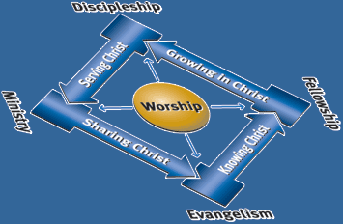

Below is a illustration of the 3-step assimilation process at The Journey using a section of the Purpose Driven Church baseball diamond model. Moving a person from home plate to first base involves the 3-step process of first time guests becoming second time guests, second time guests becoming regular attenders, and finally regular attenders becoming fully developing members.

A person reaches first base and concludes the assimilation process when he or she signs the Membership Covenant at the conclusion of Membership Class and becomes a member.

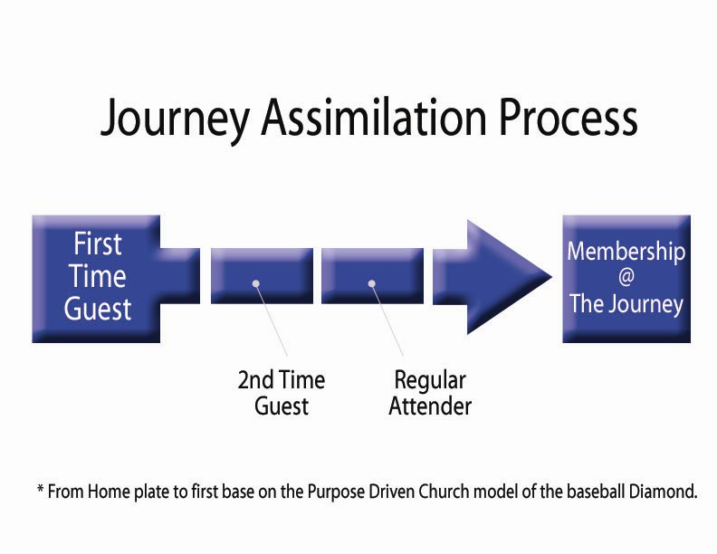

The following is a detailed outline of The Journey’s Assimilation process. Included is an overview of follow-up from when a person visits The Journey as a first-time guest to when he/she becomes a member. Also included are samples and descriptions of the materials that we have used effectively to encourage individuals to take the next step toward becoming a fully developing member at The Journey. We are confident that anyone can adapt these ideas and materials to use at his or her own church.

Assimilation Overview

A. First Time Visit

- A person attends The Journey for the first time and fills out a Connection Card.

- Following the service, a first time guest receives a free book and can visit the Fresh Start Table to ask questions or talk with a member or staff person.

- The person receives an email within 36 hours of attending a Journey service. This e-mail includes a link to an on-line survey that encourages feedback from the first visit and connects the person to The Journey’s web site.

- The person receives a hand-written note in the mail within 96 hours of attending a Journey service. This note includes an unexpected gift to “wow” the first time guest in addition to a postcard describing the current series. The gift is relevant to the target demographic.

- The person receives in the mail a typed letter approximately one month after the 1st visit. Included in the letter is another gift and an audio message CD from a prior service.

B. Second Time Visit

- A person attends The Journey for the second time.

- The person receives an email within 36 hours of the 2nd visit. This e-mail focuses on a specific way the person can get connected at The Journey.

- The person receives a typed letter in the mail within 96 hours of the 2nd visit. Included in the letter is a second “surprise” gift that someone in the target demographic appreciates.

C. Regular Attender

- A person is encouraged and has opportunities to sign up for Service Teams, Play Groups, Growth Groups, Baptism, and Membership Class on a weekly basis.

- A person is eligible to attend Membership Class after attending The Journey regularly for 2 months.
I. Step #1: From First Time Guest to Second Time Guest

The first goal is to move an individual from the role of a first time guest to a second time guest. Many people will visit a church for the first time, but it is a big challenge to get a person to return for a second visit.

When a person visits The Journey for the first time, we focus on 3 areas to encourage that person to return for a second visit.

A. Pre-Service: First Contact

The first impression a person develops of a church and of the people who make up the church is the most important impression. It’s very difficult to shake a first impression.

The first impression that most first time guests have when they visit the church is not formed by the message, the music, or even the overall presentation of the service. The first impression is formed by how the person is greeted, directed, treated, and seated by those serving at the Worship Service.

These 4 areas of first contact are vitally important for a first time guest to have a positive impression of the church.

1. Greeted:
A first time guest wants to be greeted with a smile in a friendly and welcoming way without being bombarded or made to feel uncomfortable. They want to know that you are glad they are there.

- Directed:
A first time guest wants to be directed to where he or she needs to go in a simple and polite way. He/she wants to know where to go, where the restrooms are, and where to find information about the church. Having no direction adds anxiety and greatly reduces the positive impact of a church’s first impression.

- Treated:
A first time guest wants to be treated well. Again they want to be treated with respect and in a way that makes him or her feel like the church is glad that they are there. An important way to do this is by making high-quality food and/or snacks readily available. This makes a great first impression and is something that will pleasantly surprise the first time guest. They won’t forget that your church cared enough to feed them.

- Seated:
A first time guest wants to be helped to their seat in a way that prevents them from worrying about finding a place to sit or interrupting everyone else. They want finding a seat to be easy and stress free. Ushers are very important to making a first time guest feel comfortable and to helping them form a positive first impression of the church.

Note: Remember, regardless of music performance or message deliverance, a person must be welcomed into the church in a friendly and helpful way or the first impression of the church will be a negative one, and it will be unlikely that he/she will ever return a second time. The feedback we hear over and over again from first time guests who have a positive first impression of The Journey is seldom related to the music or the message. Most of the time it is related to how they were made to feel when they first walked in the door.

B. During the Service: Connection Card

Follow-up with first time guests is only possible if you collect their contact information in a simple, comprehensive, and non-threatening way. If a first time guest visits the church and you fail to gather contact information, you have lost all ability to follow-up and assist in moving him/her from a first time guest to a second time guest status.

At The Journey we use what is called a Connection Card (many churches use the term “communication card”) to collect the information of first time guests. It is a simple card that is easy to fill out. On the card we collect contact info, prayer requests, and any spiritual “next steps” (steps of growth) that an individual feels he/she needs to take in response to the service that day.

See Appendix A for a sample of The Journey Connection Card.

The teaching pastor announces that first time guests may drop a completed Connection Card in the Offering Buckets in exchange for a free book after the service (see Fresh Start Table below).

In order to make the Connection Card more effective for collecting the contact information of first time guests, we ask that everyone (including regular attenders and members) fill out Connection Cards as well. Everyone places a completed Connection Card into the Offering Buckets as the ushers pass them at the end of the service.

Note: Whether or not a church uses a Connection Card, it is imperative that it finds an effective and non-threatening way to collect the contact information of all first time guests. Otherwise, follow-up is impossible.

C. Post Service Gift: Free Book

Immediately following the service, all first-time guests with potential to return to our church are offered a free gift, usually a book, as a sign of our appreciation for their attendance. We choose a book that is relevant to a person who might not be a regular church attender – such as The Case for Faith by Lee Strobel. We mention in a friendly way that the free gift is for in-town guests only. We only ask that a first time guest drop a completed Connection Card in the Offering Buckets before picking up the book at the Fresh Start Table after the service (see below).
D. Post Service Information: Fresh Start Table

The offer of a free book encourages first time guests to visit the Fresh Start Table where the books are located. At the Fresh Start Table in the lobby, a first time guest who made a decision during the service or who has questions about the church or Christianity can find a knowledgeable person to talk to, more resources, and information about the church. We staff the Fresh Start Table with a church member or staff person who can answer questions about the church. The table also displays free resources such as information on becoming a Christian, baptism, membership, the church’s beliefs, and new believer’s bibles. All of these resources are free and communicate the church’s concern for spiritual growth in a non-threatening way.

E. Post Weekend: Follow-Up

The Monday following the service presents the time to follow-up with those who attended the church for the very first time that weekend. Remember, a church can only do this if it has collected contact information from first time guests effectively.

1. First Response Team
Initially the pastoral staff has to do all of the follow-up themselves. However, as the church begins to grow it becomes unproductive and unrealistic to expect the pastoral staff to personally be responsible for every bit of follow-up correspondence that goes out in their names.

At The Journey we have what we call the “First Response Team.” This team meets on Monday afternoon (after all of the information from Sunday’s Connection Cards has been entered into a database) to write personal cards from the pastors and to send out e-mails to first and second time guests.

Note (a word about phone calls and personal visits): At The Journey, we do not follow-up with first time guests (except on rare occasions) with phone calls or with personal visits. In New York City, especially for those who may have little or no church background, phone calls and personal visits might come across as intimidating. Thus, we focus our follow-up on e-mail and regular mailings. Phone calls and personal visits are reserved for those who are connected to the church already or who specifically ask for such.

2. 36 Hour Response via email
At The Journey we believe in following-up with first time guests by contacting him/her within 36 hours. This means that by the end of the day on Monday for a Sunday service the guest must be contacted. We do this via e-mail. Every first-time guest receives a personal e-mail from the Teaching Pastor that Sunday thanking him/her for attending and offering the church’s assistance in any needs it can possibly address. The email will always possess the name of the Teaching Pastor as the sender since that is the name that a first-time guest is going to recognize and feel comfortable with. For that reason, as a church might grow and create a volunteer team to do this, make sure the name of the sender is always the Teaching Pastor from that Sunday.
Within the e-mail is a link to a first time guest survey on The Journey’s web site. This serves two purposes. It provides feedback concerning the first time guest’s initial experience at The Journey. We use these surveys as a way of evaluating ourselves. Also, the link to the first time guest survey takes the person to The Journey’s web site where he/she can look around, find out more about the church, find ways to get connected, and perhaps strengthen a connection to the church.

See Appendix B for a sample of our first time guest e-mail and Appendix C for a sample of our on-line first time guest survey.

Note: Correct to the best of your ability any emails that are returned due to an incorrect e-mail address.

3. 96 Hour Response via mail
At The Journey we follow up with first time guests with a second contact within 96 hours. This means the guest should receive a second contact from the church by the end of the day on Thursday if he/she attended the church on Sunday (assuming the Connection Card was filled out effectively).

We make this second contact with a hand-written card from the Teaching Pastors (since that is the name that a first-time guest is going to recognize and feel comfortable with) sent via mail. Along with the card we include a Journey Subway Map, a $4 Metro Card, and a series-specific postcard. All are ways of making a first time guest feel special, of creating a “wow” effect by giving something that is useful, and of encouraging a first time guest to check out the church for a second time. All gifts are relevant to the culture of the target group.

See Appendix D for a sample of our first time guest card.

Note: These gifts are obviously specific to a New York City setting. So, be creative in what gifts you might be able to give first time guests that would “wow” them and encourage them to visit your church for a second time.

Note: Why such a fast response time with follow-up? We cannot over-emphasize how valued a first time guest feels when contacted the day after visiting a church for the first time. They recognize that they are a priority to the church and are more likely to come back for a second time.

4. One Month Follow-Up via mail
Approximately one month following a person’s first visit to the church, we send a letter from the pastors indicating that it has been a month since the first visit. In the letter we thank and encourage the guest. We also include an audio message CD of one of The Journey’s previous messages. Again, choose a gift that relates to the culture of your target group.

See Appendix E for a sample of our one-month follow-up letter.
II. Step #2: From Second Time Guest to Regular Attender

The second goal is to move an individual from being a second time guest to becoming a regular attender. If you do a good job creating a positive first impression and worship experience, and you are intentional and thorough with your follow-up processes, you have a better chance at seeing first time guests become second time guests at your church.

While this is a big step, the next step is even more difficult. How do you encourage a second time guest to attend your church on a regular basis?

When an individual returns to The Journey for the second time, we focus on two areas as being important to encouraging that person to become a regular attender.

- During Service: Connection Card

A second time guest also has the option of filling out a Connection Card (see “Connection Card” above) to collect the information of Second time guests. On the card we collect contact info, prayer requests, and any spiritual “next steps” (steps of growth) that an individual feels he/she needs to take in response to the service that day. These next steps are options that people can choose that engage a person more deeply into the church.

See Appendix A for a sample of the Journey Connection Card.

B. Post-Weekend: Follow-up

As with our first time guests, immediate follow-up with second time guests is vitally important. Again, we focus on 36 and 96 hour follow-up.

1. 36 Hour Response via email
At The Journey we believe in following-up with second time guests with a personal contact within 36 hours. This means by the end of the day on Monday for a Sunday service. We do this via e-mail again. Every second-time guest receives a personal e-mail from the Teaching Pastor that Sunday that thanks them for attending and asks if there is anything the church can do for them.

In addition, the second time e-mail focuses on getting the individual plugged into the church in a different area. For instance, if we are in the middle of small group sign-ups, this e-mail is a great way to encourage the person to join a group by providing a link to the small group sign up web page. You might also promote a fun event at the church or offer them the opportunity to plug into a Service Team at the church. It’s never too early to ask someone to serve.

See Appendix F for a sample of our second time guest e-mail.
2. 96 Hour Response via mail
At The Journey we believe in following up with second time guests with a second personal contact within 96 hours. This means they should receive a second personal contact from the church by the end of the day on Thursday if they attended the church on Sunday (assuming they shared with you both their e-mail address and their mailing address).

We do this with a typed letter from one of the pastoral staff. Included in the letter is a $5 Starbucks Gift Card or one free Blockbuster movie rental as a way of thanking and encouraging the second time guest. By this time, a second time guest begins to see that your church is friendly, generous, and cares about them

See Appendix G for a sample of our second time guest letter.

3. One month follow up
Don’t forget, the second time guests will receive the one month follow up on the one month anniversary of their first visit to the church.

C. Post-Weekend: Engagement Opportunities

Second time attendance indicates an interest in getting more deeply connected. Be sure to offer second time guests opportunities to get plugged into the church beyond the Sunday service. This can be done through the “Next Steps” options on the Connection Card. We have found that if first and second time guests don’t get connected at the church beyond the Sunday service, there is a much lower probability rate that they will ever become regular attenders.

Offer second time guests the following opportunities to get connected when available and be sure to follow up on positive responses throughout the week:

- Small groups
It is important that second time guests begin to form relationships with people at the church. The longer it takes, the more unfriendly they are going to think the church is and the less connection they will have to the church. Remember, everyone is looking for healthy relationships. The more healthy relationships a person forms, the more likely they are to keep returning to the church and taking the important next steps in their spiritual growth.

2. Fun events
At The Journey we have specific events called Play Groups. These are events like coffee houses, flag football, movie nights, etc. where people can meet others and have a great time together in a safe and fun environment. Fun events go a long way to making a person feel comfortable and connected to a church.
3. Service Teams
It is never too early to ask someone to serve. After all, they are created to serve! When a person serves in a simple position (such as a greeter, program distributor, etc.), it does three things.

a. One, it makes that person feel alive. He/she is doing what God created people to do – serve other people. It is fun.

b. Two, it provides a personal sense of ownership in the church. The sooner a person serves, the sooner he/she begins to feel that the church is his/her church.

c. Three, it provides an opportunity to build relationships with other people in the church. Relationships are the number one factor in a person feeling connected to a church.

See Appendix H for a sample of our Service Team Sign-Up Card.

III. Step #3: From Regular Attender to Member

The third goal in the assimilation process is to move an individual from being a regular attender to becoming a fully developing member. The commitment to membership is one a person must take in his/her spiritual journey to become a fully developing follower of Jesus. It requires a process to move a person from regularly attending to taking the next step of membership.

A member is a person who has developed ownership, pride, and identification with the church and chooses to become a part of a spiritual family. This requires the creation of relationships and responsibilities within the church. A regular attender says, “This is the church I go to.” A member says, “This is MY church.”

- During the Service

1. Service Opportunities
Serving at the church provides a sense of ownership and pride in the church. Committed service is often the final step in moving a person from an attitude of “I attend this church” to one of “This is MY church.”

As mentioned above, it is never too early to plug someone into one of your Sunday Service Teams. Also, encouraging a regular attender to participate in servant evangelism projects that promote your church to the community is another way to build attitudes of ownership, loyalty, and excitement towards the church as well as a heart for the community.

We often ask people to take a spiritual gifts inventory as a way of discovering which area of service God has best gifted them for. We consistently teach on and encourage people to discover their SHAPE (spiritual gifts, heart, abilities, personality, and experience). A person’s SHAPE will determine the how, where, what, and how of their service.

2. Teaching on Baptism and Membership
In order for regular attenders to take the next step and become members, it is important that your church continually extols the values of membership and baptism on Sundays. This can be done by regularly teaching on membership and baptism and continually talking about how important both steps are to a person’s spiritual growth.
As a part of teaching on membership and baptism, there are three elements that can be added to a worship service to effectively share about and build excitement for membership and baptism.
a. One way to encourage people to become members and to participate in baptism is through the use of personal testimony in the Sunday service. Nothing is more powerful than when someone who everyone in the crowd can relate to shares how God changed his/her life in a positive way due to becoming a member or being baptized. Some people may not listen to a pastor, but they will listen to a person who has experienced life-change and is willing to share about it.
b. Another method of using video in the Sunday service is to show prepared clips of previous Membership Classes and baptisms. Video is as close as a person can get to the live experience without actually being there. Video helps people see how exciting and life-changing both events are and how normal people participate in them. Also, people often want to see before they will actually do, and a video clip helps to satisfy that need.

c. It is important that when you teach on membership you communicate that becoming a member of a church is not joining an organization, it’s joining a family. Becoming a member at a church means that you are becoming a part of a spiritual family and are joining a family of believers on the most important and exciting "journey" you will ever take.

See Appendix I for possible teachings on why people need to be part of a spiritual family and to view The Journey’s membership requirements.

3. Signing up for Baptism and Membership Class
It should be as easy as possible for a person to express interest in and participate in either Membership Class or baptism. Here is the Journey’s process:

a. Promote the value of Membership and baptism to Regular Attenders during the services, through groups, and via e-mail.

b. Sign Regular Attenders up for Membership Class.

i. On Sundays they can check a box on the back of their Connection Card expressing interest in either Membership Class or baptism.

ii. During the week they can express interest for Membership Class or baptism on our web site by filling out a simple form.

Note: Upon receiving an indication of interest in either membership or baptism, that person will receive a phone call and the church will send them an information e-mail that shares the details about the upcoming Membership Class or baptism and invites them to participate.

You can view samples of baptism and membership e-mails in Appendix J and Appendix K.

Note: Once a person attends Membership Class at The Journey he/she must still sign the Membership Covenant to become a member. A membership covenant is vital in securing the new, family relationship.

You can view a sample of The Journey’s Membership Covenant in Appendix L.
B. Post-Weekend: Small Groups

Small groups are the “powerhouses” of the church and are the centers from which you are most likely to encourage regular attenders to become members.

People who are plugged into small groups are building relationships within the church and are taking “next steps” (growth steps) in their spiritual lives. They are the people in the church who are most likely considering becoming members because they are taking their spiritual walk and their participation in the church seriously.

1. Notify regular attenders about available or up-coming small groups

a. Have a small group catalogue with small group options and opportunities to sign up available at the weekend service.

b. Promote small groups via e-mail or in your church’s weekly church-wide e- mail or news letter to regular attenders.

c. Promote small groups on your church’s web site and provide on-line sign-ups.

2. Take opportunities to target the people in your small groups for membership
Allow your small groups to be venues from which you can periodically share about the value of church membership and promote the next membership class. Make sure your group leaders are members or are becoming members and that they are encouraging the people in their groups to do so as well.

It is those regular attenders who are in small groups who are most likely to be the next members of the church. So, moving people into small groups and promoting membership through small groups is a key step in moving people from being regular attenders to becoming members.

Appendix

Appendix A:

Journey Connection Card

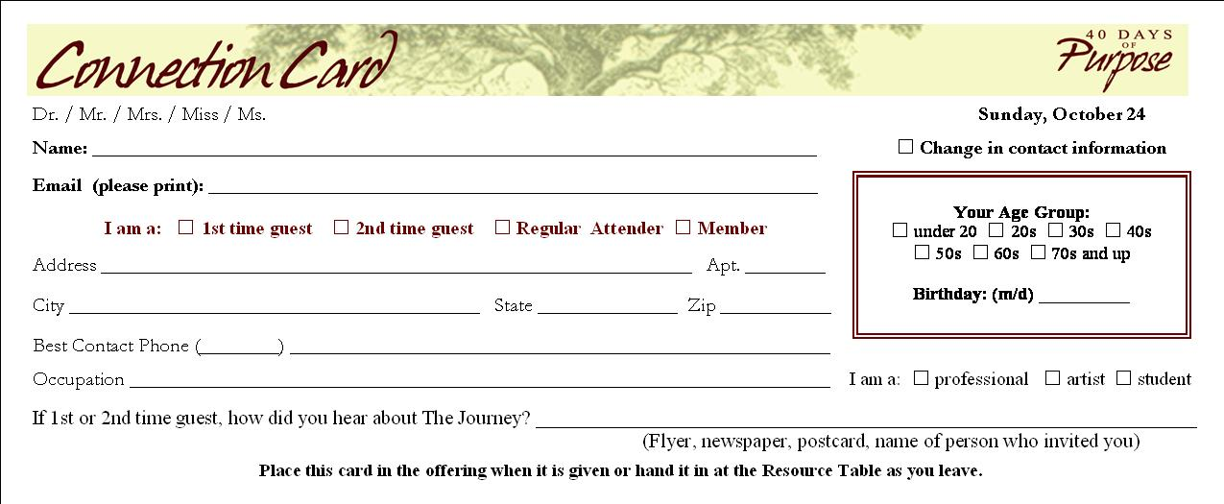

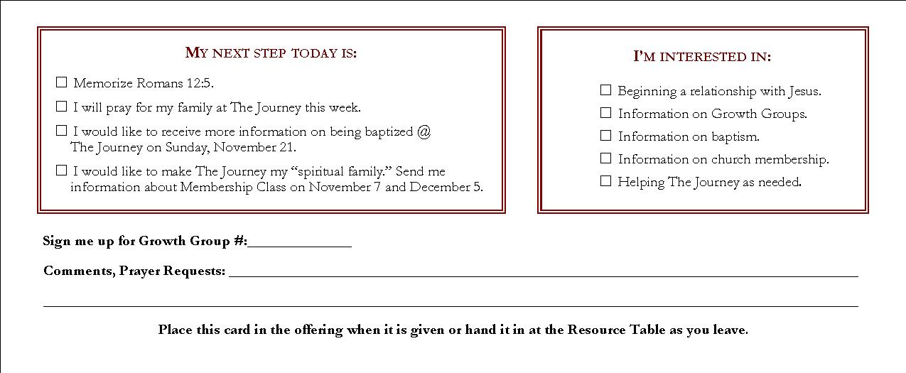

Appendix B:

FIRST TIME E-MAIL
(to be sent ASAP on Monday – within 36 hours of the service)

Subject: Great to see you @ The Journey
From: Teaching Pastor of that Sunday

Hi [add first name here],

It was great to see you on Sunday at The Journey. We hope your time with us was both relevant and meaningful to your life - and that you had a good time too.
We wanted you to know that we will be praying for you this week. If there is anything we can do for you or if there is a specific way that we can be praying for you...please feel free to let us know - after all, that's what we are here for.
If you have some time this week, it would be great if you could reply to this e-mail or fill out our on-line survey at www.nyjourney.com/survey/ and let us know what you thought of your first time at The Journey. What were your impressions? Did you feel welcomed and comfortable? Was your first time at The Journey a useful and/or meaningful experience? Do you have any questions? It means a lot to us to hear from those who have just come to The Journey for the first time, so your input will be greatly appreciated.
Again…great to see you on Sunday. I hope that you will join us again soon at The Journey.
Have a great week.
God bless...
Pastor Nelson and Pastor Kerrick (depending on who teaches that Sunday)
The Journey
www.NYJourney.com
PS - Don't forget...this weekend we kick off “40 Days of Purpose” @ The Journey. Everyone who attends will receive a FREE copy of “The Purpose Driven Life.” You will not want to miss it! I look forward to seeing you then.

Appendix C:

FIRST TIME GUEST ON-LINE SURVEY
(a link to the survey is included in the First Timer E-mail)
Guest Survey
Thank you for visiting The Journey recently! You matter to us and so does your opinion. We would appreciate your feedback on the following four questions:
Top of Form
What Did You Notice First?
What Did You Like Best?
Overall Impression?
How Can We Pray for You?
Name?
Email Address?
Bottom of Form

Appendix D:

FIRST TIME CARD
(hand-written note with $4 Metro Card, Subway Map, and Series Post-Card – mailed on Monday or Tuesday at the latest)

Hi [add first name here],

Great to see you on Sunday @ The Journey. We hope your time with us was both meaningful and relevant to your life – and that you had a good time too ☺

Enclosed is a $4 Metro Card – good on all NYC subways and buses. So, take a short “journey” on us!

We hope to see you again soon @ The Journey. Have a great week, and God bless…

Nelson & Kerrick

Appendix E:

FIRST TIME ONE-MONTH FOLLOW-UP LETTER
(with Audio CD from previous service)

September 17, 2004

Hi [add first name here],

Thank you for visiting The Journey for the first time last month – in August. We want to express our appreciation to you for taking the time to check us out!

We hope that you have found The Journey to be a welcoming, relevant, and fun place to get plugged in and meet other people. We also hope you have found The Journey be a place where you can encounter God and have a meaningful worship experience. We are a church where you can be yourself with other people who are on a similar “journey.”

To celebrate your one month anniversary @ The Journey, we wanted to do something special for you to show our appreciation. Enclosed is a $5 Blockbuster Gift Card. I hope you enjoy it ☺

There are a lot of cool things going on right now at The Journey. In just a few weeks we will be kicking off our Fall Growth Groups. Growth Groups are our small groups of 8-12 people who meet together weekly to grow, build new relationships, and have fun. We will have over 60 groups to choose from. We hope you are able to get connected. You can sign up for the group of your choice on Sunday or by visiting our web site @ www.nyjourney.com.

In the meantime, please let us know if there is any way that we can be praying for you or if there is anything that we can do for you. Also, if you have any questions about The Journey or how you can get plugged in, feel free to let us know.

Have a wonderful week, and we look forward to seeing you again soon @ The Journey! God bless…

On the journey together,

Pastor Nelson & Pastor Kerrick
The Journey
www.NYJourney.com

PS – Also, I have enclosed an audio CD from one of our previous services during our “Stress Free Living” series. I hope you enjoy it and find it relevant to your life!
Appendix F:

SECOND TIME E-MAIL
(to be sent ASAP on Monday – within 36 hours of the service)

Subject: Great to see you @ The Journey
From: Teaching Pastor of that Sunday

Hi [add first name here],

I'm glad that you were able to join us again Sunday @ The Journey. It's good to know that we did not scare you off after your first time with us :-) I hope you enjoyed your second time with us as we talked about “The Power of Positive Purpose.”
There are a lot of easy ways to get plugged in at The Journey this Fall. If you have not signed up already, you can sign up for the Growth Group of your choice on any Sunday or during the week anytime on our website @ www.nyjourney.com/gg. I hope you decide to get plugged into one of our small groups.
I will be praying for you this week...if there is anything specific that we can be praying for you about, if you have any questions, or if there is anything we can do for you this week, please don't hesitate to let me know.
Have a great week, and God bless...
Pastor Kerrick
The Journey
www.NYJourney.com

PS - Don't forget...this weekend we kick off “40 Days of Purpose” @ The Journey. Everyone who attends will receive a FREE copy of “The Purpose Driven Life.” You will not want to miss it! I look forward to seeing you then.

Appendix G:

SECOND TIME LETTER
(with one free Blockbuster movie rental – mailed on Monday or on Tuesday at the latest)

October 4, 2004

Hi Tiffany,

It was great seeing you again at The Journey on Sunday. We hope you had a fun and meaningful experience with us as we talked about the “Power of Positive Purpose” and getting involved in The Journey’s upcoming “40 Days of Purpose.”

We’re excited that you chose to check out The Journey a second time. As a result, we wanted to do something nice for you to show our appreciation. Enclosed is a $5 Gift Card to Starbucks. Take a friend and have a good time ☺

This month is a great time to sign up for a Growth Group @ The Journey. Growth Groups are The Journey’s small groups of 8-12 people who meet together weekly. Our Fall 2004 groups begin this month and last through the middle of December. You can sign up for the group of your choice on Sunday or on-line at www.nyjourney.com.

Please let us know if there is anything we can do for you or if there is a specific way that we can be praying for you this week. Also, let us know if you have any questions about The Journey and how you can get plugged in further.

To find out more about The Journey and all that’s going on, be sure to visit our web site at www.nyjourney.com.

We look forward to seeing you on Sunday. Have a great week, and God bless!

On the journey together…

Pastor Kerrick
The Journey
www.nyjourney.com

PS - Don't forget...this weekend we kick-off “40 Days of Purpose” by asking “What on Earth Am I Here For?” Everyone who attends receives a FREE copy of “The Purpose Driven Life.” You will not want to miss it! We look forward to seeing you then.
Appendix H:

Service Team Sign-Up Card

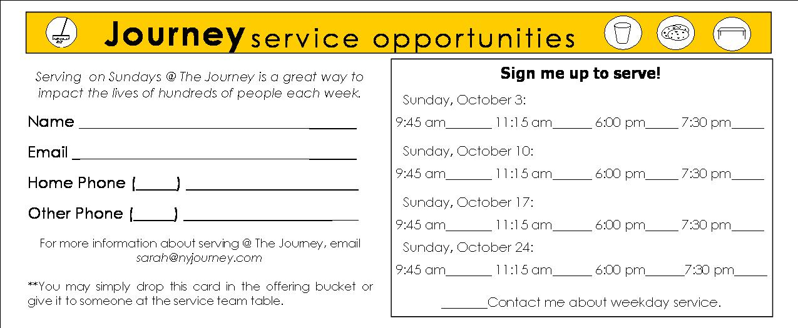

Appendix I:
Why do you need a spiritual family?
- YOU NEED HEALTHY RELATIONSHIPS.
"Two are better than one, because they have a good return for their work: If one falls down, his friend can help him up. But pity the one who falls and has no one to help him up!" - Ecclesiastes 4:9-10
- YOU NEED A PLACE WHERE YOU CAN USE YOUR GIFTS.
"Do not neglect the gift that is in you, which was given to you…" - 1 Timothy 4:14
- YOU NEED A PLACE WHERE YOU CAN GROW.
"They joined with the other believers and devoted themselves to the apostles' teaching and fellowship, sharing in the breaking of bread and prayer." - Acts 2:42
- YOU NEED TO BELONG TO SOMETHING BIGGER THAN YOURSELF.
"Just as each of us has one body with many members, and these members do not all have the same function, so in Christ we who are many form one body, and each member belongs to all the others." - Romans 12:4-5
"Let us not give up meeting together, as some are in the habit of doing, but let us encourage one another…" - Hebrews 10:25

What are the personal requirements for membership @ The Journey?
- SALVATION - a personal relationship with Jesus Christ
- BAPTISM - adult believers baptism by immersion
Two months of faithful attendance @ The Journey

Appendix J:

BAPTISM FOLLOW-UP E-MAIL

Hi [add first name here],
Thank you for expressing interest in being baptized @ The Journey. I want to make you aware of The Journey's next baptism on Sunday afternoon November 21.
Unless plans change, the baptism will be held from 1:30 - 2:30 PM at First Baptist Church located on the northwest corner of 79th Street and Broadway. It is only a short 3 block walk from The Journey's Upper West Side location at the Promenade Theater.
If you have any questions, feel free to let me know. You can also read more about what the Bible says about baptism and about The Journey's beliefs on baptism at http://www.nyjourney.com/resources/baptism.asp#meaning.
If you have begun a relationship with Jesus, I would love for you to participate in this very special time of baptism. All you need to do right now is respond to this e-mail as soon as possible and let me know whether or not you are planning to join us on November 21.
I look forward to hearing from you and hope you can participate with us on November 21.
Have a wonderful week.
Blessings...
Pastor Kerrick

Appendix K:

MEMBERSHIP CLASS FOLLOW-UP E-MAIL

Hi [add first name here],

Thank you for expressing interest in Membership @ The Journey. I'm excited that you are considering making The Journey your spiritual family.
The Journey's next Membership Class is coming up this Sunday October 10 from 1:30 - 4:30 PM...and we would love for you to be a part.
There is only one requirement for attending Membership Class. By October 10 you need to have been attending The Journey for two months. If you meet that requirement, then you are qualified to attend Membership Class. If not, then our next two classes will be in on November 7 and December 5.
By attending Membership Class you are NOT making the commitment of becoming a member (although you will have the option of becoming a member at the end of the class). Membership Class is an opportunity for you to explore membership @ The Journey, to find out more about The Journey, and to ask any questions that you might have.
All you have to do is reply to this e-mail and let me know whether or not you are planning on attending Membership Class on Sunday October 10. It is important that you RSVP for this class, so I look forward to hearing from you soon.
Thanks again, and I will be praying for you as you consider taking this important step.
God bless...
Pastor Kerrick
Appendix L:

JOURNEY MEMBERSHIP COVENANT

1. I will protect the unity of my church.

. . . by acting in love toward other members
. . . by refusing to gossip
. . . by following the leaders

2. I will share the responsibility of my church.

. . . by praying for its growth
. . . by inviting the unchurched to attend
. . . by warmly welcoming those who visit

3. I will serve the ministry of my church.

. . . by discovering my gifts and talents
. . . by being equipped to serve by my pastors
. . . by developing a servant’s heart

4. I will support the testimony of my church.

. . . by attending faithfully
. . . by living a godly life
. . . by giving regularly

____________________________________________ _______________
Signature Date

