How to Do a Journey-style
Servant Evangelism Saturday

By John Troy
Director of Community Outreach,
The Journey

Servant Evangelism (SE) Defined
Servant Evangelism is sharing the love and message of Jesus Christ through practical acts of service and kindness. Servant Evangelism is a biblical, fun, simple, and intentional way to make sharing Jesus a lifestyle.

Servant Evangelism Described
Servant Evangelism can be done individually or as a group. Here is the simple concept: an individual or group begins doing intentional acts of kindness in their community with the aim of evangelism. A simple act of kindness opens an unbeliever up to the greatest act of kindness of all: the Gospel.

Servant Evangelism involves two parts: Service (i.e., acts of kindness) and Evangelism. Many people in our culture today believe that the church is only concerned with getting something from them. By doing Servant Evangelism, the church is doing more than just being nice. It is breaking down one of the major barriers that keep people from experiencing the Gospel.

Servant Evangelism is a wonderful expression of the Great Commandment and the Great Commission. It is great for people who are first learning how to share their faith, as well as the most seasoned Christian.

Servant Evangelism Saturday Defined
A Journey-style Servant Evangelism Saturday is a once a month event held on a Saturday designed to engage attenders of the church in Servant Evangelism. The events are designed so that anyone can participate effectively – no prior training or preparation on the part of the participant is necessary.

Generic Project Calendar: Key Tasks

- Select Date

- 3 Weeks Before Your Selected Date
  - Design series specific card about your church for use during the event

  - Place date and brief information on your church calendar (Don’t forget your website calendar)

- 2 Weeks Before
  - Select Project (See Appendix 5)

  - Select Location

  - Contact Group Leaders of the groups that are signed up for the upcoming event
    - Remind them about the event

    - Ask them to get a count of how many people from their group will be attending

  - Provide some information in Sunday program on the upcoming event

  - Print the series specific card about your church

- 1 Week Before
  - Flyer in Sunday program on upcoming event

  - Brief information in your weekly newsletter on the event

  - Call Group Leaders and collect a number from their group on who will be attending

  - Email Group members directly and remind them about the event

  - Purchase and prepare supplies and materials for the event

- Post-Event
  - Debrief on event with key leaders

  - Begin developing plan for the next Servant Evangelism Saturday

The Journey System for Servant Evangelism Saturday

Select the date for your next Servant Evangelism Saturday at least 3 weeks in advance.

At The Journey, we believe it is important to build as much consistency into the date so that people can begin to plan their schedules around your servant evangelism events. Generally, The Journey holds their Servant Evangelism Saturdays on the second Saturday of every month.

Be sure to select the date at least 3 weeks in advance to allow for proper planning and scheduling time.

Decide upon a Servant Evangelism project at least 2 weeks in advance.

Select a specific project at least two weeks in advance of the date.

There are countless servant evangelism projects that your church can participate in. Things to consider when deciding upon a Servant Evangelism project include:

How many people are you planning on involving?

Quality vs. Quantity of Servant Evangelism touch

Every time someone benefits or receives an act of service, this is considered a servant evangelism “touch”.

Often, how deeply you serve someone affects the amount of people that you are able to serve. However, a deeper touch, by definition, makes a longer lasting impact upon an individual and may make the fewer touches worthwhile. Therefore, over the long-run, it is important to achieve a balance between Quality and Quantity.

What time of year is it? Are there seasonal projects to consider?

What is the weather typically like this time of year?

How much money are you willing to spend per touch? In total?

Are you trying to reach a particular demographic?

How will you purchase the supplies?

Remember, evangelism is an investment in the future, not an expense!

Participants are often willing to donate $10 to the project to provide for supplies if necessary

How will you transport the supplies?

Select the location for your Servant Evangelism Saturday at least 2 weeks in advance.

Select the location at least two weeks prior to the event. This will allow you adequate time to inform everyone of the location of the project before the event.

Choose an area with a high amount of local traffic. Avoid locations with high amounts of tourists or non-residents, as they will not be able to respond to your servant evangelism project by attending your church.

Make sure the project that you have chosen will work well in the location that you choose. Will the typical demographic in the area appreciate the type of service you plan on doing? **

** Note: If the location and project are not a match, then one or the other must change. Everything should center on the people you are trying to reach. Never sacrifice the goal of your project (reaching people for Jesus and involving them in your church) for a specific location or servant evangelism project.

Make sure the project is conducted in a location that contains a high amount of traffic in your target demographic. The location you choose should have people that match your church culture.

Mobilize volunteers to serve during your Servant Evangelism Saturday. The Journey mobilizes volunteers to serve at Servant Evangelism Saturday through the following four ways:

Small Groups: At the start of each semester, every small group is assigned a Servant Evangelism Saturday for that semester. Servant Evangelism Saturdays are open to anyone to participate, however to ensure strong participation from the church’s attenders, small groups are all asked to attend one Servant Evangelism Saturday per semester.

Two weeks before their scheduled Servant Evangelism project, the groups should be reminded about their scheduled SE date via email.

One week prior to their scheduled SE date the leaders of each Growth Group should receive a phone call reminding them about that Saturday’s servant evangelism project.

In addition, one week prior the Servant Evangelism leader for your church should email the assigned attendees directly to remind them about the upcoming SE event.

Each group will need to respond to you with an estimated attendance from their small group. This will enable you to better plan for servant evangelism supplies at the project.

Sunday Flyer: Beginning 2 Sundays before the Servant Evangelism Saturday, The Journey places a flyer in the program for the upcoming event.

This flyer provides the time, location, date, and contact information for people regarding the SE Saturday.

Those who are interested in attending are encouraged to email a specific representative, who will be able to use this number to plan out how much to provide in Servant Evangelism supplies.

Newsletter

This is a weekly email newsletter sent out to your church’s database containing information on upcoming events at your church. A brief overview of the Servant Evangelism Saturday should be included here for the two weeks preceding the event. Those who are interested in attending are encouraged to email a specific representative.

Example:

Servant Evangelism Saturday
Want to make a real difference in someone’s day? Then join us Saturday afternoon on October 16th for Servant Evangelism Saturday! Servant Evangelism is a fun, easy, and meaningful way to share the love and message of Jesus through acts of service. For more information, email john@nyjourney.com.

Website

On the church’s website, you should have a calendar of events that provides a brief description of the church’s upcoming events. As soon as the date has been set for your Servant Evangelism project, this date should be placed upon the website calendar.

Example of brief description:

Servant Evangelism Saturday
Want to make a real difference in someone’s day? Then join us Saturday afternoon, October 16th, at 12pm at Father Demo Square in the Village for Servant Evangelism Saturday! Servant Evangelism is a fun, easy, and meaningful way to share the love and message of Jesus through acts of service. For more information or to RSVP, please email john@nyjourney.com

Additional Pre-Event Preparation

The supplies for your event must be purchased and prepared to be used at your SE Saturday. Where you purchase the supplies and what preparation work is required to get ready for the event is entirely dependent upon which project you have chosen. Depending on the project, The Journey has found great success with local warehouse stores, such as BJ’s or Sam’s Club.

With each project, printed material must also be included. For example, if you are giving away water in a park on a hot summer day, each recipient must receive a bottle of water and a card about the church. The card about the church is often the only communication you are able to have with the recipient, so it is important that you include all the information about your church that they need to know. Information should include:

Service times and locations

Message series information

Title of the series

Titles of the Sunday messages and their corresponding dates

Church website

Servant Evangelism Saturday

Pre-Event: All necessary supplies and printed material must be transported to the site and prepared as much as possible for the participants.

Event

Approximately 5 to 7 minutes after the planned start of the project…

Welcome everyone and thank them for coming

Conduct a brief, 5 minute training on Servant Evangelism

Define Servant Evangelism

        - Share some basic examples of SE (perhaps past projects, etc.)

        - Briefly explain the biblical basis for it

        - Explain the impact that it has already had at your church and how God has been using it. Often times people do not understand how powerful a tool Servant Evangelism truly is. Explaining the impact Servant Evangelism has had at your church can truly motivate people.

Walk them through the key points on your church’s card

- Service Times and Locations

- Message Information and Dates

- Website

Conduct an overview of the project you will be doing that day

Explain the project. For example, if you are going to be giving away free bottles of water, explain what that means, etc.

- Explain the team structure for the project. In other words, how are you going to organize the volunteers? Let them know if they will be going out with a group of 2, 3, 4 etc.

- Explain to them what to say as you do the project

Depending on the project, Servant Evangelism can be as simple as saying “Would you like a free granola bar?”

If asked why, respond: “We just wanted to show you God’s love in a practical way.”

If they are asked a question they do not know the answer to, remind them not to make it up. You can:

Direct the person to the church website

Apologize for not knowing the answer, but offer to put them in touch with someone at a Sunday service who does.

Remind them to hand every recipient of the service a church card as well.

Tell them to smile!

Encourage them to pray throughout the event.

Answer any questions that they might have

Announce a time to meet back after the project. Most projects work well if they are approximately 60 – 90 minutes.

Pray

Divide the group into teams

Distribute supplies and let the teams serve

Throughout the event, be on the lookout for potential servant evangelism leaders for your church. Provide on the spot feedback to these leaders so that they can develop their servant evangelism skills.

Post-Event Wrap Up

Collect left over materials (postcards, servant evangelism supplies, etc.)

Ask everyone how it went

Provide an opportunity for people to briefly share some stories

Answer any questions they may have

Remind them once again of the importance of what they did today

Thank them for coming and let them know when the next Servant Evangelism Saturday will be

Pray and Close

Clean-up after the event (pick up any cards on the sidewalk, etc.)

Return supplies, equipment, left over materials, etc.

Count the number of touches.

Going Forward

To the best of your ability, track the number of first-time guests who attend your church in the weeks after the project that can be attributed to that Servant Evangelism Saturday

Save those statistics and inform your SE participants in the future. Don’t underestimate the ability of numbers of changed lives to inspire people!

If possible, contact everyone and thank them once again for coming. Go ahead and remind them of the new project date.

Start developing key servant evangelism leaders. Have them read books, visit websites, etc. to expand their knowledge

Conspiracy of Kindness, By Steve Sjogren [the Text-book on servant Evangelism]

www.servantevangelism.com

www.epicteam.org

Irresistible Evangelism, By Steve Sjogren

Plan your next Servant Evangelism Saturday!

Appendix
- Sample Servant Evangelism Training Flyer
- Additional Sample Servant Evangelism Training Flyer
- SE Saturday Promotional Flyer from a Sunday Program
- Sample Series Postcard
- Sample Project List

Appendix 1) Sample Servant Evangelism Training Flyer

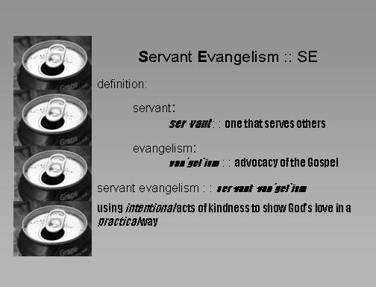

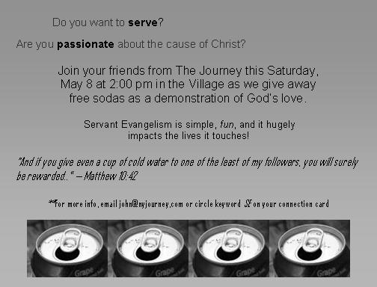

Appendix 2) Additional Sample Servant Evangelism Training Flyer

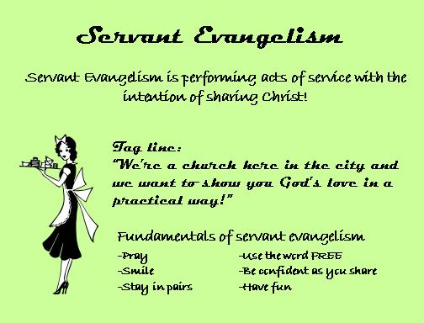

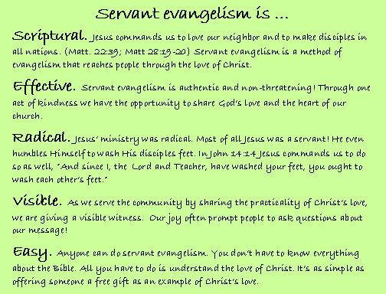

Appendix 3) Servant Evangelism Promotional Flyer from a Sunday Program

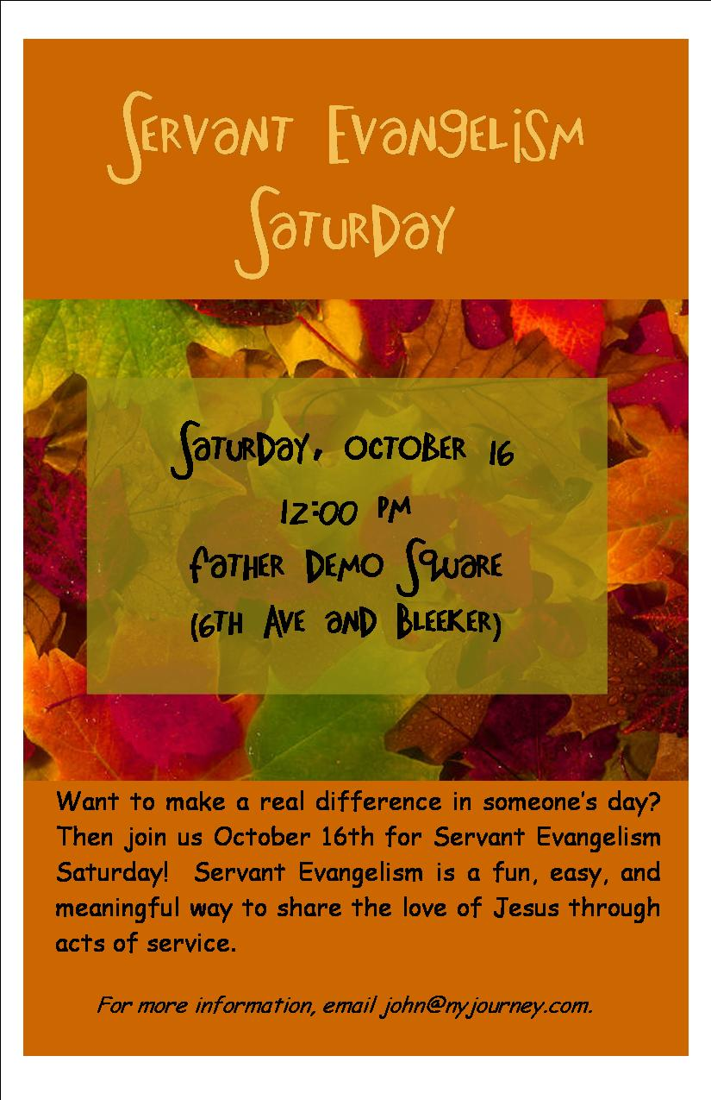
Appendix 4) Sample Series Postcard



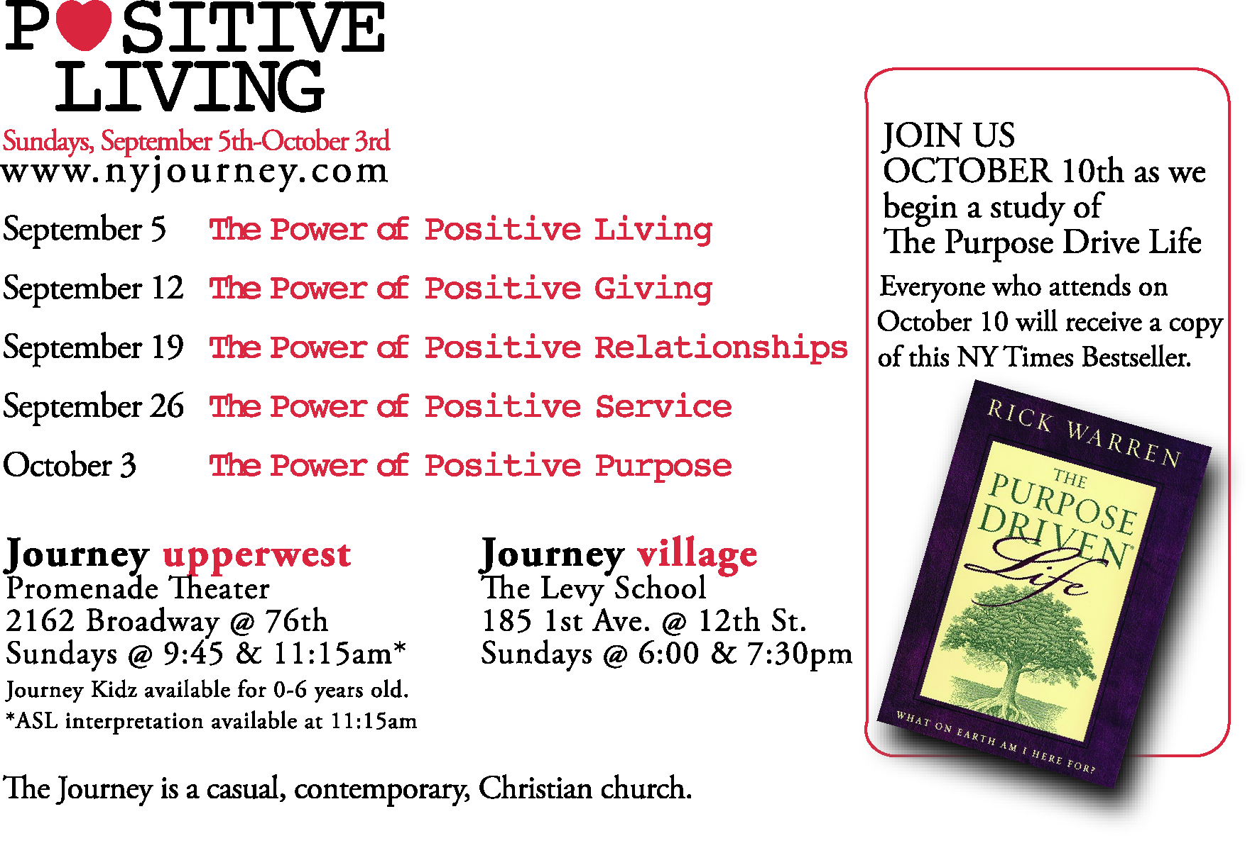
Appendix 5) Sample Project List



Below is a list of 10 Servant Evangelism Ideas you can begin using right now!

10 SERVANT EVANGELISM IDEAS

1. Free Car Wash (and yes, we do mean free, even if they insist).

2. Distribute free cups or bottles of water on a hot day.

3. Give out packs of gum at a ballpark.

4. Wash car windshields (leave a kind note behind).

5. Beautify the community (a nice way of saying trash pick-up).

6. Partner with a local gas station to offer free gas, oil changes, or tire checks.

7. Pay for someone’s dryer at a Laundromat.

8. Pay a toll for the person behind you.

9. Hand out free lights bulbs -- door to door or in a city park.

10. Offer to return shopping carts.

These are just 10 of hundreds of ideas you can do as Servant Evangelism projects. To add a special dimension to your projects, select 2 or 3 people to prayer walk the surrounding area.

Provided by The Journey Church of the City, New York City, NY

