Series Design Package Franchise Overview
April 27, 2005

By Jung Hoon Kim

A Journey Church Franchise ©2005

Series Design Package Franchise Overview
3.29.05

ASSUMPTIONS
- Message series have been determined by the teaching team
- Locations and dates have been established for services
- Access to a designer or design team who has all the necessary software (see below) and design tools
- Software Needed: Adobe Photoshop, Illustrator, Acrobat and Indesign
- All design will be done on either PC or MAC computer

KEY OBJECTIVE
To create a cohesive visual face for the churches message series through printed publicity pieces (postcards, advertisements), designed graphic elements for the Sunday Service (program, connection cards, scripture memory verse cards, PowerPoint slides) and on and off stage signage (banners, signs).

OUTLINE
- POSTCARD
  - Preparation for design
  - Design
  - Proof and approval
  - Preparation of final design to be sent to printers

- SUNDAY SERVICE ELEMENTS
  - Sunday Program
  - Message Notes Header
  - Connection Card
  - Scripture Memory Card
  - PowerPoint
  - Design Specifications & Post-Design Procedures

- PUBLICITY
  - Print
  - Web

- SIGNAGE
  - Showcase

- APPENDIX
- POSTCARD
All series deign elements are extrapolated from the initial full color series postcard design. This is the starting point in the design package. Once this project is completed it makes the development of other elements much easier and gives a unity and overall cohesiveness to the whole design package.

  - Preparation for design
    - SERIES GENESIS
Creative Planning Meeting
This should happen approximately one month prior to the start date of the new message series. The teaching team along with the worship arts team should communicate with each other the upcoming series titles (including any subtitles) and discuss, in depth, the themes, feel and tone of the series.
IMPORTANT: This will need to be communicated to the designer or design team so take good notes!

    - POSTCARD COPY
All copy (any text) for the front and back of the series postcard must be gathered and prepared. This will be given to the designer or design team.

Below is the copy that is needed for every postcard design.
FRONT* (see appendix 1)
- Series title and sub-title
- Church web address and invitation to visit the site for a free gift
  - www.nyjourney.com
Please visit our website for a FREE gift!
- The Journey Logo

*Note: For the initial design process to begin the series title and subtitle are the most critical.

BACK (see appendix 1)
- Series title and sub-title
- Church web address and invitation to visit the site for a free gift
  - www.nyjourney.com
Please visit our website for a FREE gift!
- Date that the series runs through
- A listing of each Sunday with date and message title
- Locations and times of the services
- Any time or location changes throughout the series
- Church tag line
  - The Journey is a casual, contemporary, Christian Church
- The Journey Logo
    - POSTCARD SPECIFICATIONS
The following postcard specification must be given to the designer or design team.
- Post Card Dimensions: 4” x 6”
- All designs should have a .25” bleed area
- Both front and back designs are to be in full color

Note: All copy (any text) and specifications should be given to the designer or design team in hard (paper) and soft (computer file ie. MS Word, Text file, etc) format.

  - Design
    - INSTRUCTION
Communicate clearly with the designer or design team items discussed and gathered in points I.A.2. thru I.A.3.

    - TIMELINE
- Set a 21-30 day deadline for the final design to go to print with drafts due on day 7, 14 and 18. (see timeline below)

- Day 7: Request 2 or 3 designs to look at on day 7. These designs will be review by the lead pastor and Worship Arts pastors for approval of one design. Once one design is selected the designer/team will work on this design.
- Day 14: Corrections and edits as needed
- Day 18: Semi-final draft due
- Day 20: Final proof & approval
- Day 21: Final draft sent to printers

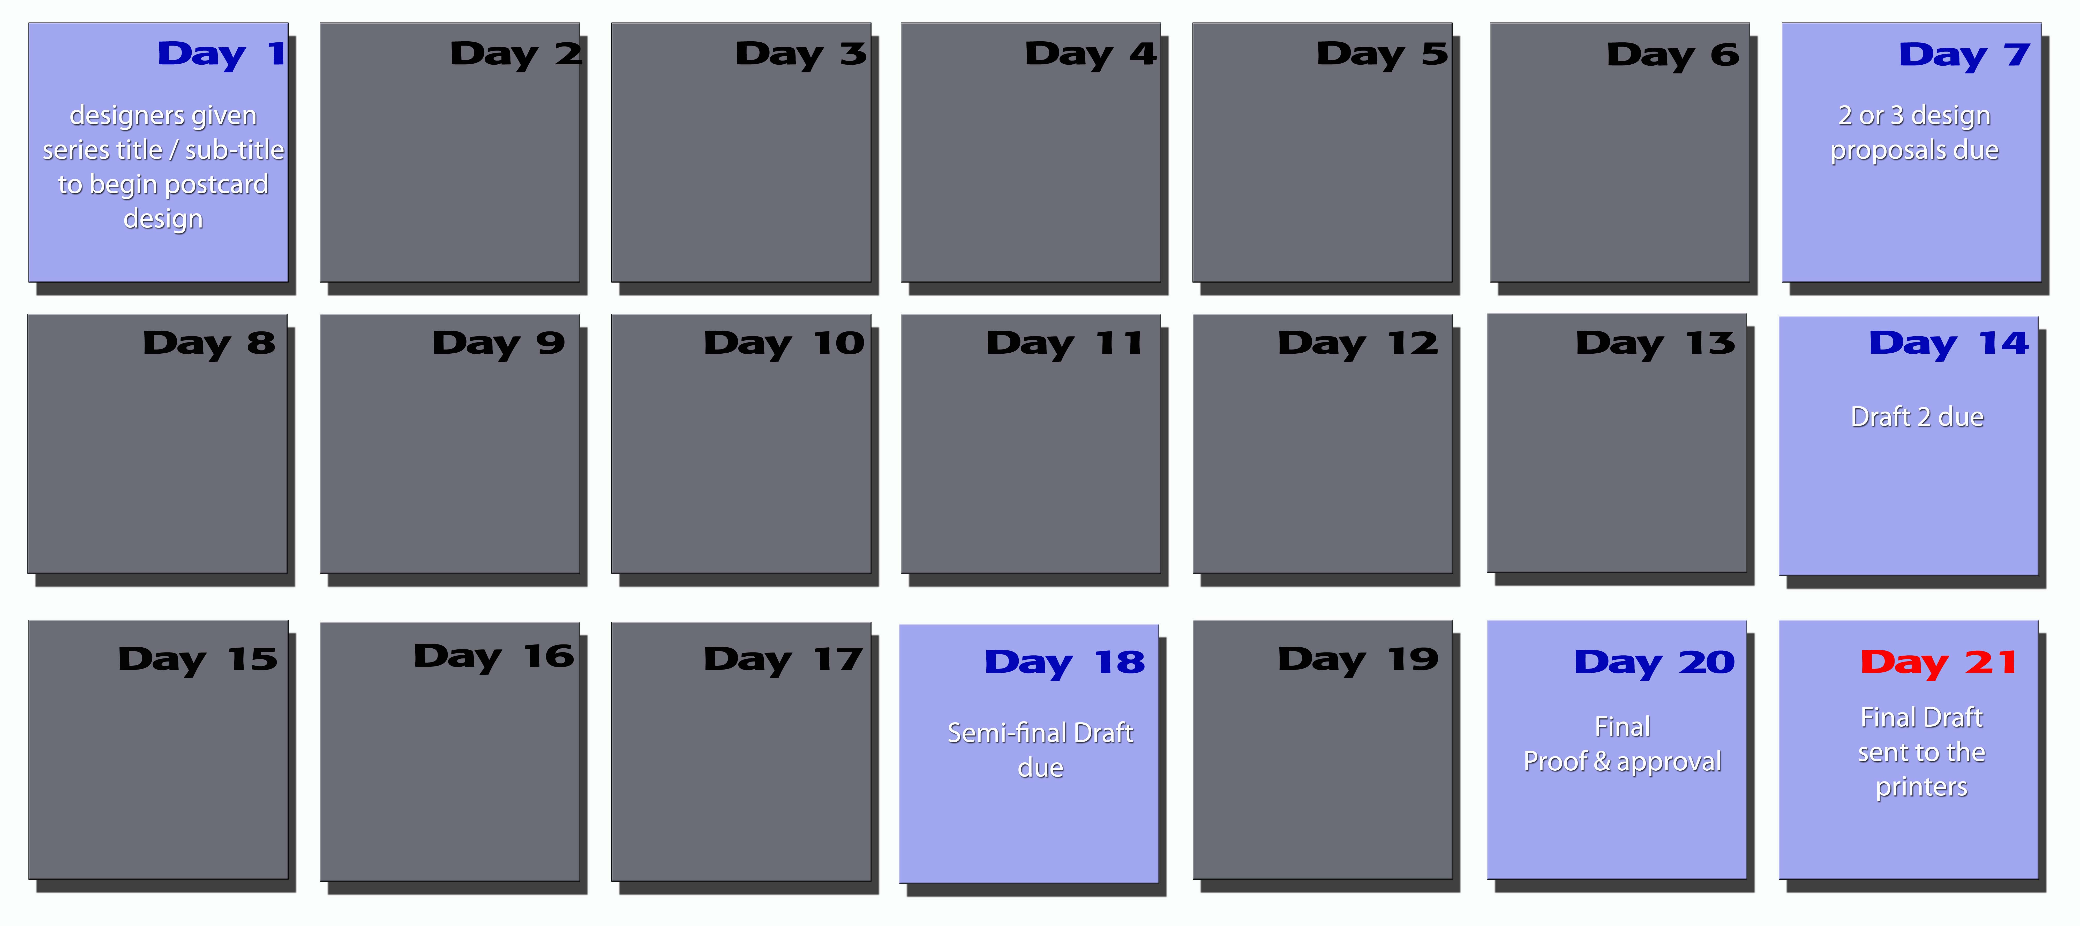

  - Proof and approval
    - FINAL PROOF
After semi-final design is prepared on day 8 make a final proof of the design. Have another person look over the design to make sure there are no mistakes or anything missing.
Note: It’s always good to have a fresh pair of eyes look at the design for this process.

    - FINAL APPROVAL
Send semi-final edited and proofed images to the lead Pastor on staff to receive the final approval before it goes to the printers.

  - Preparation of final design to be sent to printers
    - FINAL PREPERATION FOR PRINT
Once final approval is given the design must be “packaged” to be sent to the printers. This process will vary depending on what program was used to create the design. Below are instructions for packaging designs created in Adobe Photoshop or Illustrator.

PHOTOSHOP
        - All files should be saved in PSD format in both layered and flattened versions.
        - Fonts should be embedded into all the PSD files.
        - In addition a folder of all the fonts used in the design should be created*.
* Edits cannot be made by others without the proper fonts installed on their computer!
        - High resolution jpegs or PDF can be created if the printers request such formats.
        - All PSD files were made with RGB color mode must convert to CMYK color mode for print.
        - All of the above content should be burned to a CD and delivered to the Journey Office care of pastor overseeing visual arts.

ADOBE ILLUSTRATOR
- All files should be saved in AI format in both layered and flattened versions.
- Fonts should be embedded into all AI files.
- In addition a folder of all the fonts used in the design should be created*.
* Edits cannot be made by others without the proper fonts installed on their computer!
- Images should not be linked but embedded into all AI files.
- In addition a folder of all the images used in the design should be created*.
* If images where linked to the AI to regulate the size of the file these images will be needed to re-link images from these files.
- Once final design is approved covert all images and fonts should be converted to outlines. This will prevent problems with fonts at the printers.
- High resolution jpegs or PDF can be created if the printers request such formats.
- All of the above content should be burned to a CD and delivered to the Journey Office care of pastor overseeing visual arts.

- SUNDAY SERVICE ELEMENTS
The Sunday service elements consist of Sunday program, message notes header, Connection card header, scripture memory card and Sunday Power Point slides. The designs look, feel and tone of all these Sunday Service Elements should be inspired by the initial series postcard.

- Sunday Program
The Sunday program’s front and back covers are to be designed with the same look, feel and tone of the series postcard. Sunday program dimensions: 11” x 8 ½” which is divided in half so the front and back cover’s dimensions are 5 ½” x 8 ½” (see appendix 2)

- FRONT COVER
- The front cover should have the series title and subtitle
- An open area should be designed for weekly message titles and date

- BACK COVER
- “Thanks for joining us at the Journey!” should be positioned at the top of this page.
- The Journey web address, www.nyjourney.com, should be clearly visible at the bottom of this page.
- The back cover design should have three open areas to hold the following information
  - Description about the Journey
  - Staff information
  - Church location, meeting times and mailing address

- Message Notes Header
A simple page header must be designed for the loose leaf message notes page.
- Message Notes Header dimensions: 6” x 1.117”
- The Message Notes Header should contain the series title
- The series subtitle may be used but it not always needed. *
* It is preferred to using both title and subtitle but due to size and space of the element it might work best with just the series title.
(see appendix 3)

- Connection Card Header
A simple page header must be designed for the Connection Card.
- Connection card header dimensions: 8” x 0.5”
- “Connection Card” title should be part of the design
- The Connection Card Header should contain the series title
- The series subtitle may be used but it not always needed. *
* It is preferred to using both title and subtitle but due to size and space of the element it might work best with just the series title.
(see appendix 3)

- Scripture Memory Card
A business size card which will hold weekly scripture memory verses must be design.
- Scripture Memory Card dimensions: 3 ½“ x 2”
- “Scripture Memory Card” title should be part of the design
- The Scripture Memory Card should contain the series title
- The series subtitle may be used but it not always needed. *
* It is preferred to using both title and subtitle but due to size and space of the element it might work best with just the series title.
- The Journey web address, www.nyjourney.com, may be used.
- An open area should be designed for the memory verse and verse reference
(see appendix 3)

- Power Point
Several different Power Point slides must be design for the series that will be the back drop for the Sunday Service slide presentation. The slide dimensions should be 11” x 8 ½“.

- TITLE SLIDE
- The title slide should have the series title and subtitle
- An open area should be designed for weekly message titles and date

Note: a faded title slide is also need to work as an additional backdrop.
(see appendix 4)

- SONG SLIDE
- An open area should be designed for song lyrics
- An area should be designed for title and author
- An area should be designed for all CCLI information
(see appendix 5)

- MESSAGE SLIDE
- An open area should be designed for message notes
(see appendix 5)

- SCRIPTURE VERSE SLIDE
- An open area should be designed for scripture verses
(see appendix 6)

- Design Specifications & Post Design procedures

- FINAL PREPERATION
All Sunday Service Element designs must be “packaged” and given to the pastor overseeing visual arts. This process will vary depending on what program was used to create the design. Below are instructions for packaging designs created in Adobe Photoshop or Illustrator.

PHOTOSHOP
- All files should be saved in PSD format in both layered and flattened versions.
- Fonts should be embedded into all the PSD files.
- In addition a folder of all the fonts used in the design should be created*.
* Edits cannot be made by others without the proper fonts installed on their computer!
- High resolution jpegs should be created
- All PSD files were made with RGB color mode must convert to CMYK color mode for print.
- All of the above content should be burned to a CD and delivered to the Journey Office care of pastor overseeing visual arts.

ADOBE ILLUSTRATOR
- All files should be saved in AI format in both layered and flattened versions.
- Fonts should be embedded into all AI files.
- In addition a folder of all the fonts used in the design should be created*.
- * Edits cannot be made by others without the proper fonts installed on their computer!
- Images should not be linked but embedded into all AI files.
- In addition a folder of all the images used in the design should be created*.
- * If images where linked to the AI to regulate the size of the file these images will be needed to re-link images from these files.
- Once final design is approved covert all images and fonts should be converted to outlines. This will prevent problems with fonts at the printers.
- High resolution jpegs should be created
- All of the above content should be burned to a CD and delivered to the Journey Office care of pastor overseeing visual arts.

- PUBLICITY
From the initial postcard design publicity pieces are created to advertise the new series. Print and digital pieces such as newspaper and magazine ad, webpage banners and digital images are created to promote the new series.

- PRINT
Print advertisements for publication are created to promote the series to larger audiences. In the past we have advertised in newspapers such as AM New York, New York Metro, Backstage. (see appendix 7 )
In creating these advertisements use the look and feel of the initial post card design and follow the specifications requested the publication.
(see appendix 8 )

- WEB
A digital image should be created with the look and feel of post card to go on the Journey’s Website’s homepage. This will connect the overall feel of the series to churches website. (see appendix 9 )

- DIGITAL IMAGE FOR WEB
- The image can be created as a GIF or JPEG file with the following specifications:
  - Pixel Demensions: 23K / width: 185 pixels by height: 126 pixels
  - Document size: width: 2.569 inches by height: 1.75 inches
  - Resolution: 72 pixels/inch

- SIGNAGE
Depending on churches meeting location your signage needs will vary. Below are the current needs of The Journey Church, which meets at the Manhattan Center as of March 29, 2005.
Note: This is not general signage but signage that changes with the current message series.

- Showcase Sign
A showcase sign should be created with the look and feel of the initial post card design. This showcase sign is displayed out side the Manhattan Center in two of the four showcases located on 34th St and should contain the follow information:
- Clear text indicating that the church meets there
- The times of the services
- Web address of the church
- The current teaching series and dates it runs through
(see appendix 10 )

